

Registration kickoff for the Munich, Germany Station, First Session of China Shenzhen Innovation Competition of International Talents
----- Secure Your Start-Up Funding of USD 100,000,000

All information about this competition are as follows:
- About the Competition
- Procedure
- Awards and Supporting Policies

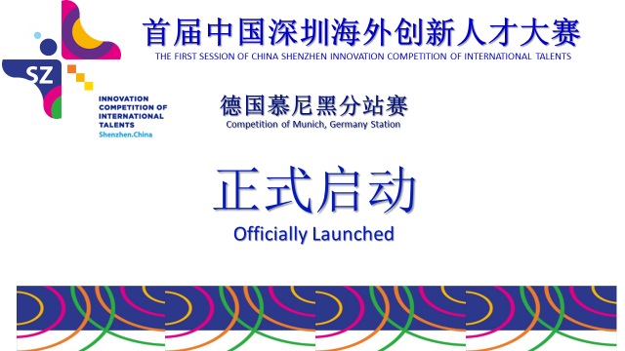
- About the Competition

The 1st Innovation Competition of International Talents, Shenzhen China (hereafter referred to as the "Competition") is led by Ministry of Science and Technology of the PR China, and State Administration of Foreign Experts Affairs, sponsored by the Shenzhen Municipal Government, and hosted by Shenzhen Longgang District People’s Government, the Shenzhen Municipal Human Resources and Social Security Bureau, and Shenzhen Science and Technology Innovation Committee. The Competition, in response to the call for "mass entrepreneurship and innovation", aims to deepen international exchanges and cooperation in innovation, further promote organic combination of talents, technology and capital, attract more international talents to start business and make development in Shenzhen, and accelerate the creation of an ecological environment of openness, integration and innovation for entrepreneurship and innovation, to help Shenzhen build an international city of entrepreneurship and innovation.
The Competition launches station competitions in five major cities around the world: Sydney Australia, Munich Germany, Tel Aviv Israel and Silicon Valley in the U.S. It is open to all overseas high-level talents, regardless of their nationality. All are welcome. The competition of the Munich Germany Station is held by the German-Chinese Association for Technology, Education and Culture Exchange (in German: Deutsch-Chinesischer Verein für Technik-, Bildungs- und Kulturaustausch e.V. , hereinafter referred to TBKV).
Except for the bonuses, the competition also sets up a one billion dollars venture capital fund for winners of the contest; cooperates with local banks and financial institutions in lending interest discount, credit rating and guarantees; provides a series of specified supporting policies in terms of office, business incubators & services and government allowance for specialists.
  - Eligibility
Participants are welcome for their experience of innovation and entrepreneurship abroad, innovative technology know-how, innovative products or management experience. They should currently reside outside China and be willing to start up own business or work in Shenzhen.
1.1.1 Participants have not yet registered and established enterprises in China before registration.
1.1.2 Participants plan to work or to register enterprise in Shenzhen in 6 months after the competition.
1.1.3 Participants have well-recognized innovation experience, are the owner of intellectual properties (IP) and/or have no IP disputes with others. Participants should be responsible for the infringement and untruthfulness.
1.1.4 Participants agree to and obey above-mentioned rules.
  - Encouraged Industrial Sectors
5 major sectors are encouraged for the contest: internet and mobile internet (information technology), electronic technology, biotechnology and life sciences, advanced manufacturing, materials and energy (including energy saving).
  - Requirement
1.3.1. If any document from the competition participant needs to be changed during the contest, a written application for the change shall be filed by the Competition Committee. The new document can be used in the following competition with authorization by the Competition Committee.
1.3.2. If participants quit the competition halfway, it will be regarded as giving up all the benefits of this competition voluntarily.
  - Judging Principles
The Competition follows the “Fair, Just and Public" principles. We will organize experts in related fields to evaluate talents by multiple perspectives: innovation experience, innovation personality, innovation ability, innovation resources, and innovation value.

Evaluation perspective | Details
Innovation experience | Innovation and business experience or experience in world-class enterprises, research institutions and universities
Innovation personality | Innovative thinking, innovation consciousness, innovation idea, innovation potential
Innovation ability | Technology, management and academic level, personal knowledge system, research results
Innovation resources | Technology, market, human resources and other social networks inside and outside of China, international insight
Innovation value | Innovation fits with industrial developments in Shenzhen

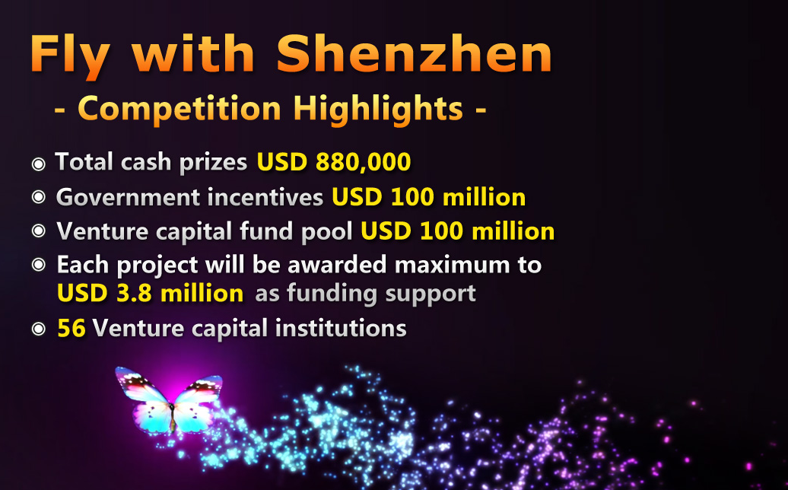
- Procedure
  - Registration
2.1.1 Log onto contest's official website (http://en.itcsz.cn/) for registration, choose the English version, then click the ‘sign up’ button, fill in the information as required. Additionally, please choose ‘Competition Site’ as well as ‘How to find us’ to be Munich, Germany, and fill in ‘Other’ with your information sources, such as the name of the recommendation association, e.g. TBKV.
2.1.2 Submission due on February 29th, 2016
2.1.3 After registration, the TBKV will invite well-known venture capital specialists to hold a training course to help participants write a perfect business plan, and achieve perfect performance in the on-site commercial roadshow of the competition.

2.1.4 Contact
Mr. Huang Tel: +4917681700478
or E-mail: info@tbkv.eu

2.2 Online Assessing
The Competition Committee will organize experts to conduct the online assessment following judging principles. Based on scores the top 10 will be invited to attend the Competition of Munich, Germany Station, and all will be invited to the cocktail party afterwards.
  - Semifinal in Munich, Germany Station
Date: April 2nd, 2016
For the 10 participants who compete at Munich, Germany Station, travelling and accommodation expenses can be reimbursed. The Semifinal in Munich will be organized in the form of live presentation and defense. 6 competitors are to be awarded the first, second and third prize, according to their scored performance. At least the first five winners are going to earn the opportunity to compete in the Longgang, Shenzhen global finals. On the day of the Munich competition, Competition Committee will hold a cocktail party afterwards, which will provide opportunities for the participants to communicate with excellent entrepreneurs and investment professionals.
  - Final in Longgang, Shenzhen
Date: April 15th, 2016
25 participants from 5 stations will be invited to attend the Longgang, Shenzhen finals. The finals will also select the first, second and third prize through live presentation and defense. A fixed budget for travelling and accommodation expenses will be provided to each finals participant.
  - Shenzhen International Talent Conference
The 25 finalists and the 6th-10th participants of each semifinal will be invited and provided certain flight ticket fees to attend the Shenzhen international talent conference held on 16-17 April, 2016 and to a tour to investigate the environment for creativity and entrepreneurship in Shenzhen.
3. Awards and Supporting Policies
3.1 Awards
NO. | Classification | Award | Quant. / team | Bonus | Required to land in Shenzhen?
1 | Finals | 1st Prize | 1 | 80,000 ＄ | Not required
2 | Finals | 2nd Prize | 3 | 50,000 ＄ | Not required
3 | Finals | 3rd Prize | 6 | 30,000 ＄ | Not required
4 | Semifinals | 1st Prize | 1 | 5,000 ＄ | Not required
5 | Semifinals | 2nd Prize | 2 | 3,000 ＄ | Not required
6 | Semifinals | 3rd Prize | 3 | 2,000 ＄ | Not required
7 | Extra awards from Longgang district of Shenzhen for finalists | 1st Prize | 1 | 400,000 RMB | Projects could apply for these awards after winning in finals and landing within 6 months in Shenzehn.
8 |  | 2nd Prize | 3 | 300,000 RMB
9 |  | 3rd Prize | 6 | 200,000 RMB

  - Policies for talents recruitment
NO. | Region | Details | Scopes and requirements
1 | Shenzhen | Talents will be awarded as C-class talent of ‘Peacock Recruitment Program for Global Experts’ and will be rewarded a minimum of 800,000 RMB. | Within 1 year after the competition, if the final winner’s project is incubated in Shenzhen or he/she signs a more than 1 year employment contract with a Shenzhen employer, limited to one person per team.
2 | Longgang District of Shenzhen | Those who have been awarded as C-class of ‘Peacock Recruitment Program for Global Experts’ and if they land the startups in Longgang district, will be awarded:  - Entrepreneurial Experts (only project leader), with extra 800,000 RMB  - Creative Talents, with extra 400,000 RMB  - And other supporting policies by Longgang district government. | 1. Within 1 year after the competition, if the final winner’s project is landed in Shenzhen Longgang district.  2. The core team member who invests more than 300,000 RMB into the startup or bears over 30% shares.  3. Only one member of the team will be awarded.  4. Fits in the scope of other supporting policies.
3 | Longgang District of Shenzhen | Policies available if landing in Longgang district:  - Entrepreneurial Experts will gain extra 200,000 RMB support.  - Creative Talents will gain extra 100,000 RMB support. | - Project landed in Longgang  - Semifinals winning project  - Preferred by policies among all projects

  - Policies for Encouraged Industrial Sectors
NO. | Region | Details | Scopes and requirements
1 | Shenzhen | Up to 1,000,000 RMB support for the startup project, which fits in the scopes and requirements. | - Project landed in Shenzhen  - Semifinals winning project  - Preferred by policies among all projects
2 | Longgang District of Shenzhen | Extra 5% of the support given by city government. | - Project landed in Longgang district  - Supported by policies in Shenzhen City Government

  - Financial, and Science and Technology Policies
NO. | Region | Details | Scopes and requirements
1 | Shenzhen | If the awarded winning project in semifinals meets the applied requirement and supportive policies of Shenzhen, and should settle down in Shenzhen, it can get preferential government equity investments. The total amount of government equity investments is 340,000,000 RMB. | - Project landed in Shenzhen  - Semifinals winning project  - Preferred by policies among all projects
2 | Shenzhen | If the awarded winning project in semifinals should settle down in Shenzhen, it can get credit promotions from banks cooperating with this competition. | - Project landed in Shenzhen  - Semifinals winning project  - Preferred by policies among all projects
3* | Shenzhen | The venture capital companies will set up a 100 Million USD venture capital fund, give portfolio investment for the excellent project, and provide professional management, consulting, business plan and other supporting services. | Any project.
4 | Longgang district of Shenzhen | The financing guarantee agencies cooperating with this competition will provide preferential financing guarantee support for participating projects; Longgang District government will provide the same amount of the loan as extra support for the startups. | - Project landed in Longgang district  - Preferred by policies among all projects
5 | Longgang district of Shenzhen | 1. Up to 10 Million RMB political government equity investment.  2. Up to 600,000 RMB loan interest discount from banks in cooperation. | - Fit in the corresponding requirements of specific policies, fit in the scope of encouraged industrial sectors of Longgang district, and land in Longgang district.  - Preferred by policies among all projects

  - Incubation and others
NO. | Region | Details | Scopes and requirements
1 | Shenzhen | If the awarded winning project in semifinals should settle down in Shenzhen, it will be prioritized to select the location in city industrial parks and incubators, and gets waiving of rent or rent subsidies and other benefits. | - Project landed in Shenzhen  - Semifinals winning projects
2* | Shenzhen | The competition provides investment docking service, including information research, project showcase, private session for participants and investment institutions. | Any project.
3 | Shenzhen | Participants settling down in Shenzhen can enjoy entrepreneurship management training, consulting, tutorials, patent applications, innovative resource sharing, professional exhibition, international exchange and recruitment and other supporting services. | - Project landed in Shenzhen  - Preferred by policies among all projects
4 | Longgang district of Shenzhen | If the project chooses to settle down in Longgang, it will:  - Get the priority to choose industrial parks or incubators in the district.  - Get half of the rent waived (up to 200,000 RMB / Year) for three years  - Get entrepreneurial training or other professional skills services.  - Get 20,000 RMB reward for each international patent per nation (up to 1,000,000 RMB per year); domestic patent 3,000 RMB (up to 500,000 RMB per year).  - Applied technology services that meetup corresponding policies, get encouraging support in the form of Sci&Tech. Coupons. | - Project landed in Longgang  - Preferred by policies among all projects

  - Appendix
- Policies listed with the regions of Shenzhen among section 3.2 to 3.5 apply to projects landed in Shenzhen, except for those marked with asterisk *.
- Policies listed with the regions of Longgang District Government among section 3.2 to 3.5 apply to projects landed in Longgang.
- Specifics about supporting policies of all kinds can be found on following websites of the governments of Shenzhen City or Longgang District:
Shenzhen Municipal Human Resources and Social Security Bureau www.szhrss.gov.cn
henzhen Science and Technology Innovation Committee www.szsti.gov.cn
Shenzhen Longgang District People’s Government www.lg.gov.cn

The official WeChat QR code of the organization committee
Innovation Competition of International Talents

The official website of the Organizing Committee:
http://www.itcsz.cn，English: http://en.itcsz.cn/

German-Chinese Association for Technology, Education and Culture Exchange (TBKV)

The official website of TBKV:
http://www.tbkv.eu

